Password Reset and Viewing Report for MI Patient Portal

- Password Reset

Click on Forgot your password?
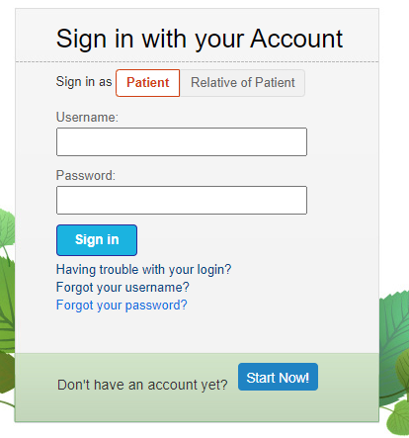
Patient will get an email with temporary password (Six-digit number). Patient can click on the Please login here link, to access the Patient Portal sign in page at https://patient.tranow.com/login.cshtml?ReturnUrl=%2f

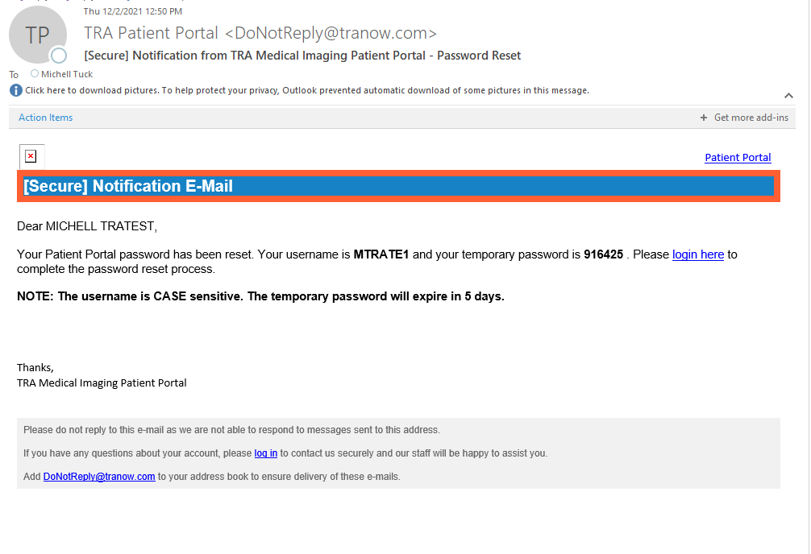

- Current Password- type temporary password (916425) hit TAB to move to next box or click on it. DO NOT HIT ENTER during this process.
- New Password- Create new password, hit TAB to move to next box or click on it. DO NOT HIT ENTER during this process.
  - 8 Characters, at least 1 upper case letter, one lower case letter, one number and one special character from [@#$%^&+=!].
- Confirm Password-Retype new password
- Choose Send Text or Receive Voice
- Once Text or Call is received, a Verification Code box will appear allowing patient to enter 6 digit code.
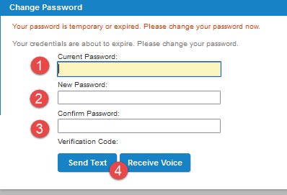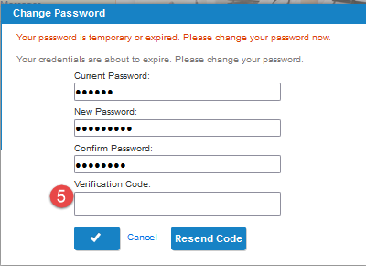

- If New Password does not meet conditions listed below a message will appear. Patients will need to retype the NEW Password with the requested criteria that will meet the conditions.
Minimum of 8 characters, One upper case letter, One lower case letter, One number and One special character (@#$%^&+=!).

- If New and Confirm Password does not match, Patient will need to re-type confirming match.
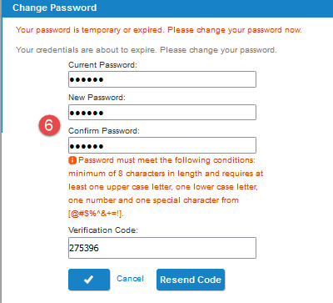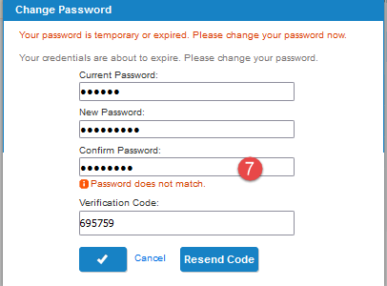

Click on blue check box to complete the change.
Hitting Enter Anytime During this process will clear out the Current Password, leaving it blank.

- If the Patient is signing in for the first time, they must set up Security Questions.
- Hit TAB to move to next box. DO NOT HIT ENTER during this process.
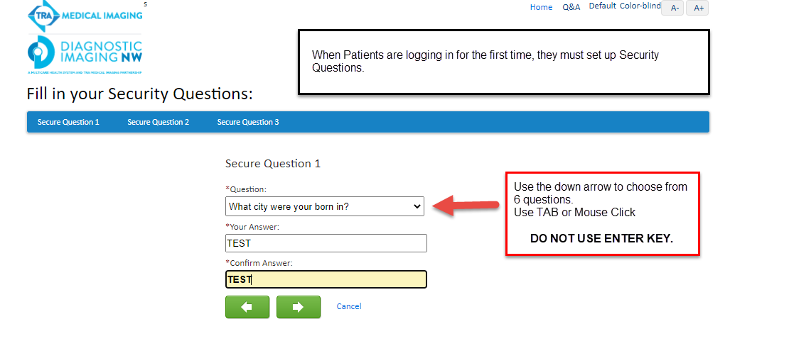
- Viewing Reports
Patient can view finalized reports by:
- Clicking on Reports Tab
- Click on Exam
- Click to view report
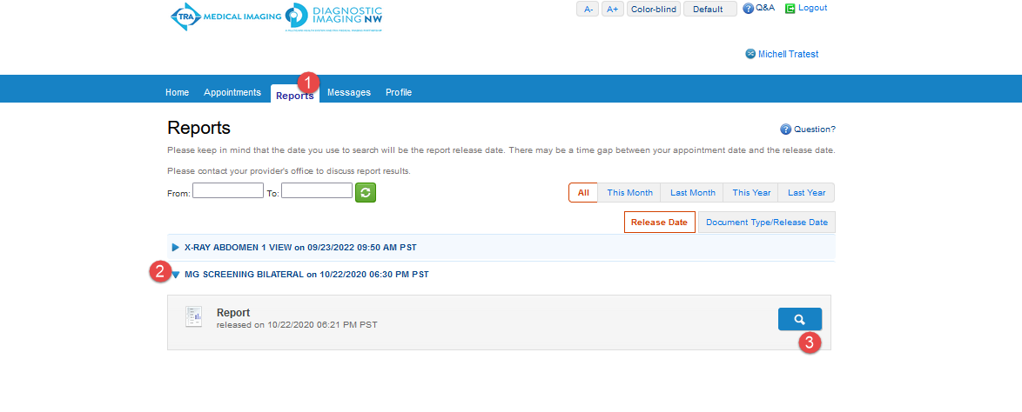
- Click Download to view entire report.
